Test Case: runTestMultipleTimes
Step 1 - Enter username and password and click to button Enter : Credentials Entered
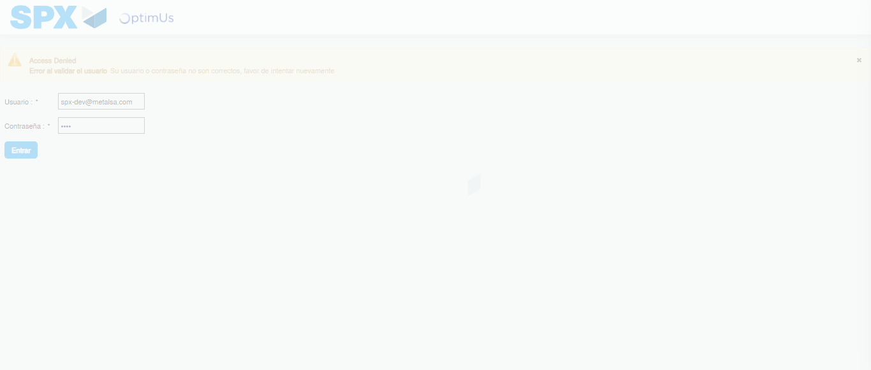Image file-name: QC_Testing-runTestMultipleTimes-dic. 04 2025, 03 39 58 p. m.

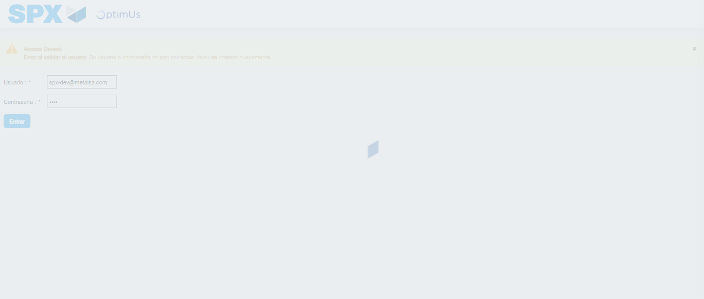Image file-name: QC_Testing-runTestMultipleTimes-dic. 04 2025, 03 39 59 p. m.

Step 2 - Select to UEN and Access to Administrador Roles Menu: UEN Correctly selected and Correct access
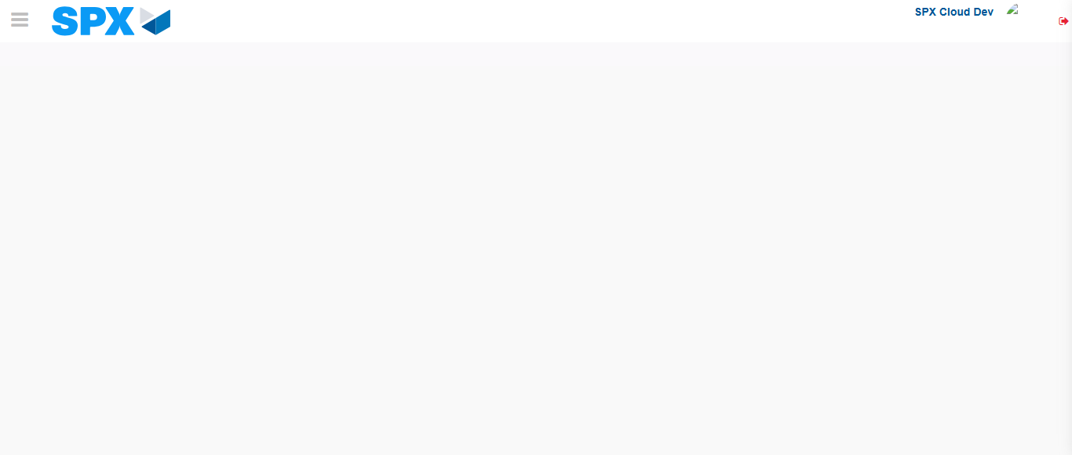Image file-name: QC_Testing-runTestMultipleTimes-dic. 04 2025, 03 40 02 p. m.

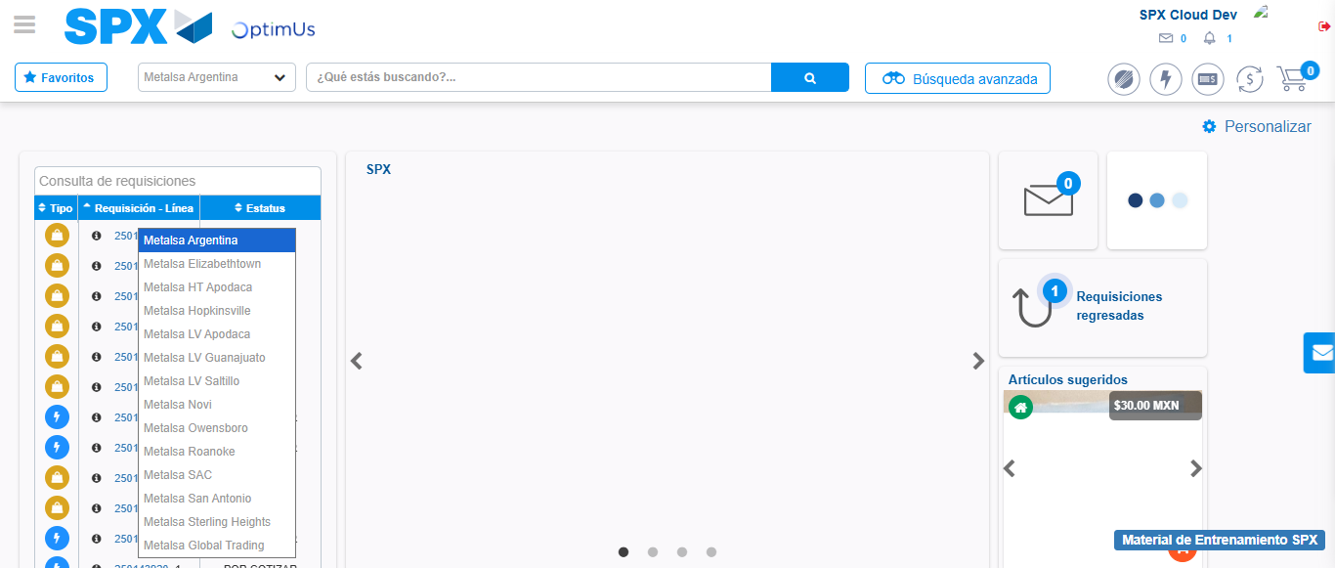Image file-name: QC_Testing-runTestMultipleTimes-dic. 04 2025, 03 40 03 p. m.

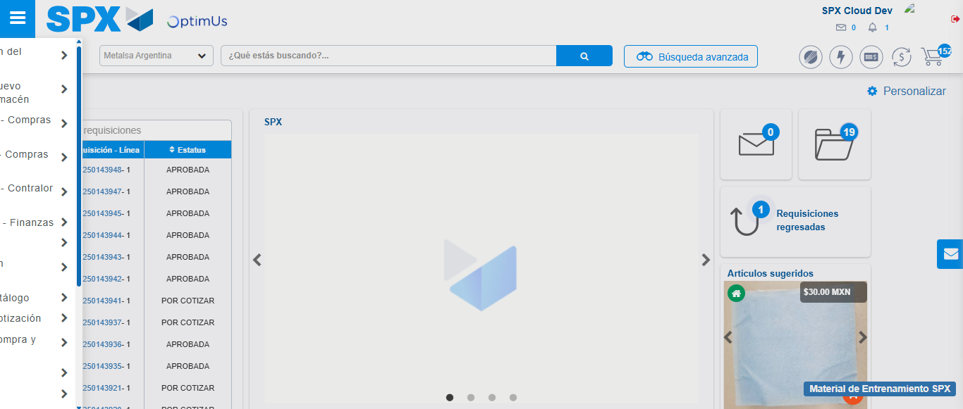Image file-name: QC_Testing-runTestMultipleTimes-dic. 04 2025, 03 40 04 p. m.

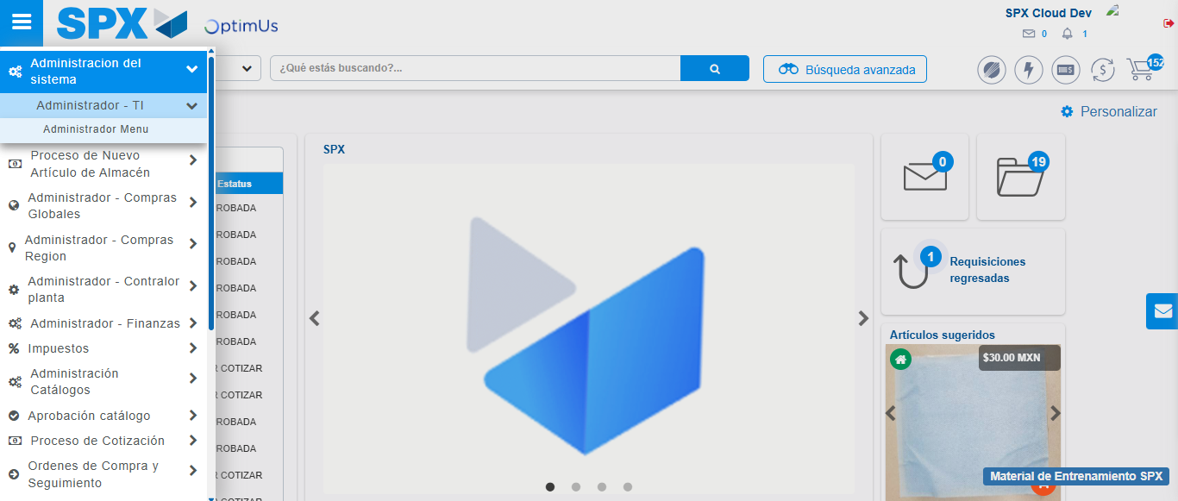Image file-name: QC_Testing-runTestMultipleTimes-dic. 04 2025, 03 40 05 p. m.

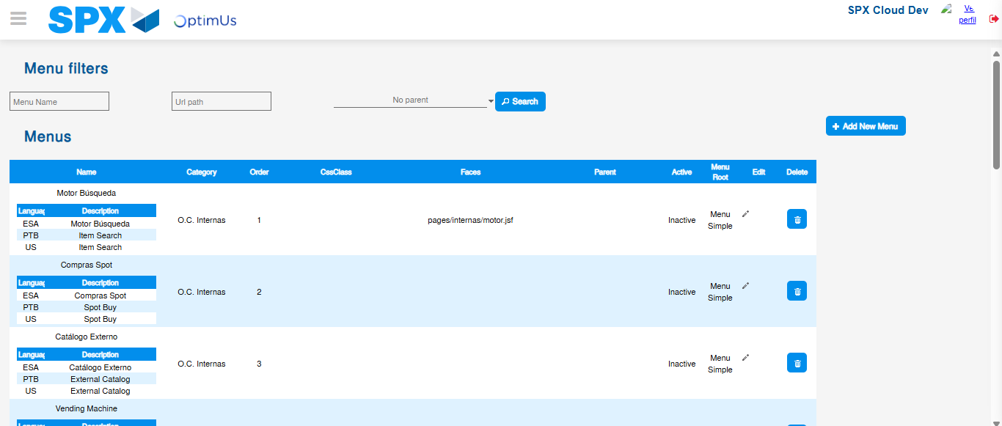Image file-name: QC_Testing-runTestMultipleTimes-dic. 04 2025, 03 40 07 p. m.

Step 3 - Perform a search with the URL Path filter: Successful search
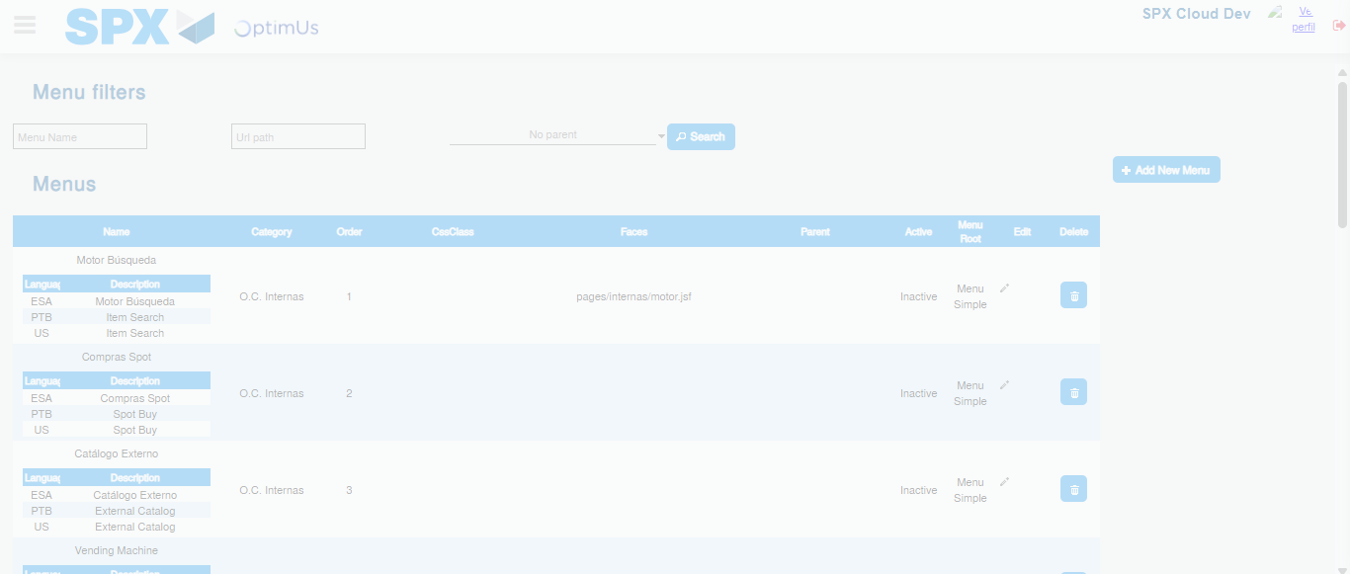Image file-name: QC_Testing-runTestMultipleTimes-dic. 04 2025, 03 40 08 p. m.

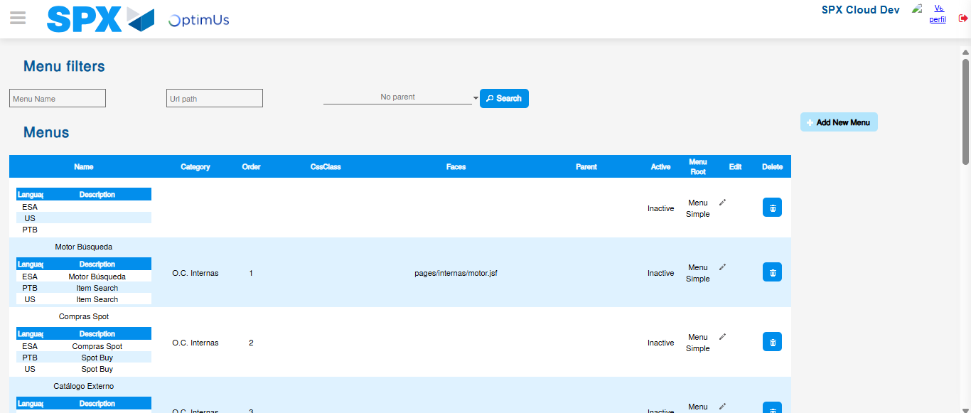Image file-name: QC_Testing-runTestMultipleTimes-dic. 04 2025, 03 40 11 p. m.

